Code Fiend 2021-22

**Blood banks Documentation**

|  |  |  |  |
| --- | --- | --- | --- |
| **Sr. No** | **Team members Name** | **Email id: -** | **Mobile No.** |
| 1 | Nisarg Jhatakia | nisargjhatakia94@gmail.com | 9512295237 |
| 2 | Harsh Shah | harshshah6137@gmail.com | 93284 33927 |
| 3 | Neeyati Mehta | mehtaneeyati@gmail.com | 98259 05655 |
| 4 | Irish Ajaybharti | Ajaybhartiirish@gmail.com | 75670 55779 |
| 5 | Yashvi Patel | 1556.stkabirnrnp@gmial.com | 9265829554 |

**Frontend Language / Technology:** CSS, BOOTSTRAP, HTML and SCSS.

**Backend:** MYSQL, PHP

**\* About Project \***

**Project Description: -**

* Today in the time of pandemic situation, the problem faced by many people is getting blood and plasma. There are many people ready to donate but the platform that can bring donor and needy people together is missing.
* We propose a Blood and Plasma Management System (website) which can bring them together and many lives can be saved. Our project idea is to store, process, retrieve and analyze information concerned with the administrative and inventory management.
* This project aims at maintaining all the information pertaining to blood donors, different blood groups available in each blood bank and help them manage in a better way.

**Proposed Solution: -**

* Our aim is to provide transparency in this field, make the process of obtaining blood and plasma from a blood bank, hassle free, corruption free and make the system effective!
* The number of people who are in need of blood are increasing in large number day by day which Is why, we have created a dynamic *responsive minimalistic website* for blood donners and blood recipients to come in contact with other.
* Our website will take care of the blood donners requirements like rejecting applications whose weight is below 50kg, having a fresh tattoo within the span of 6 months, having HIV-AIDS, took drugs, or have diseases like dengue and malaria etc.
* The website will showcase the funds raised, events created, number of blood donors successfully registered etc.
* The blood recipients can find donors in their city along with their required blood types!
* There is also a contact form created for complaints, suggestions and queries

**Competitive and Market Size Analysis – Research on other Similar Products:-**

* <https://www.friends2support.org/>
* <https://www.blood.co.uk/>
* The last website offers plasma donation which is quite useful for its UK citizens however we couldn’t help notice that, even the above popular Indian blood donation website(friends2support) didn’t offer plasma donations which could mean a life-death scenario for our Indian recipients in need.
* There is an urgent need to create a proper UI as our competitors only used offered fixed positions which is not dynamic/flexible in nature for the mobile users.
* We have used the latest fluid animations from the bootstrap 5’s properties as our competitors’ website are outdated.
* In our website we have transparently shown our funds collected which none of our competitors did so.

**Working Solution: -**

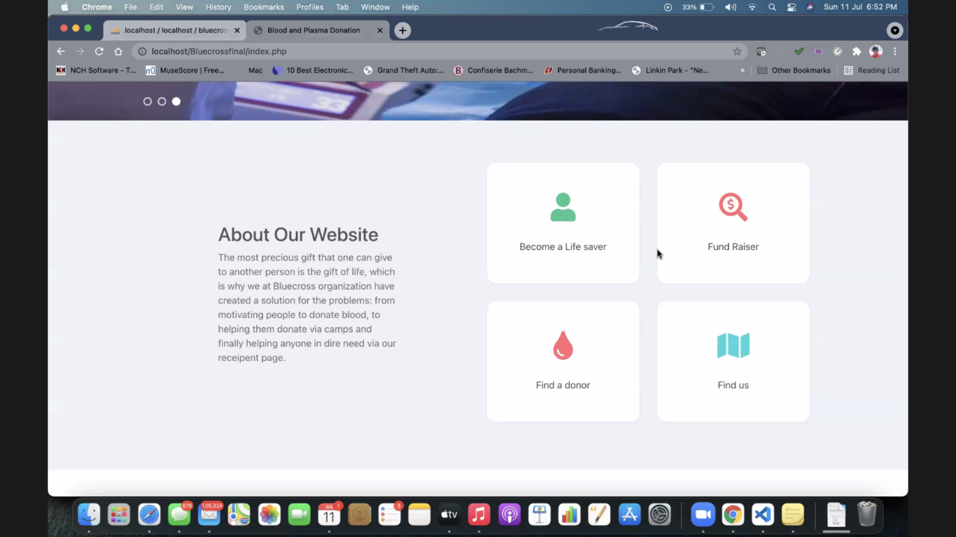

**This is our about page**

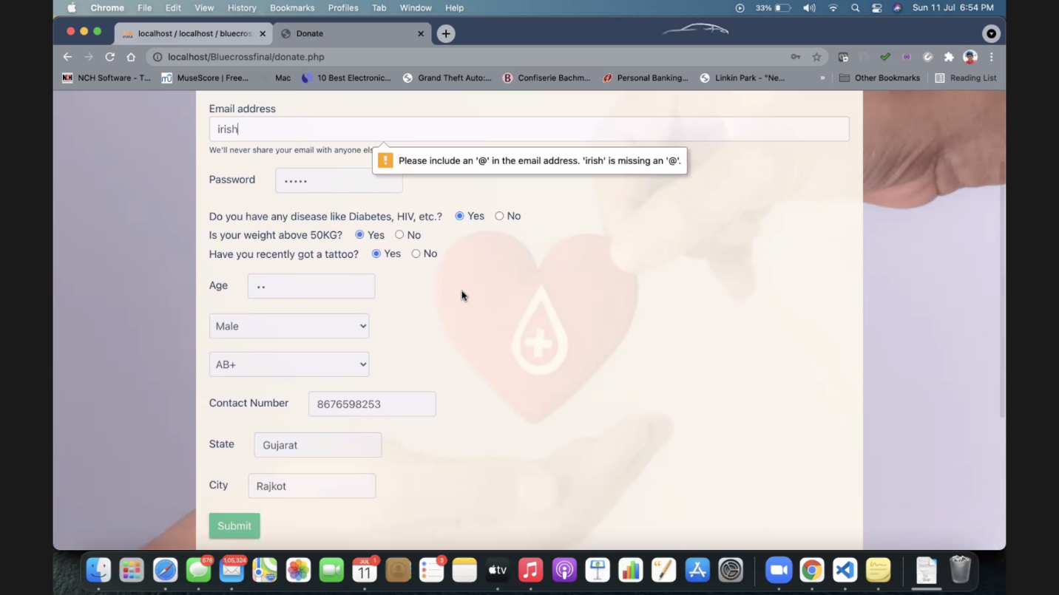

**We have added validation for the forms**

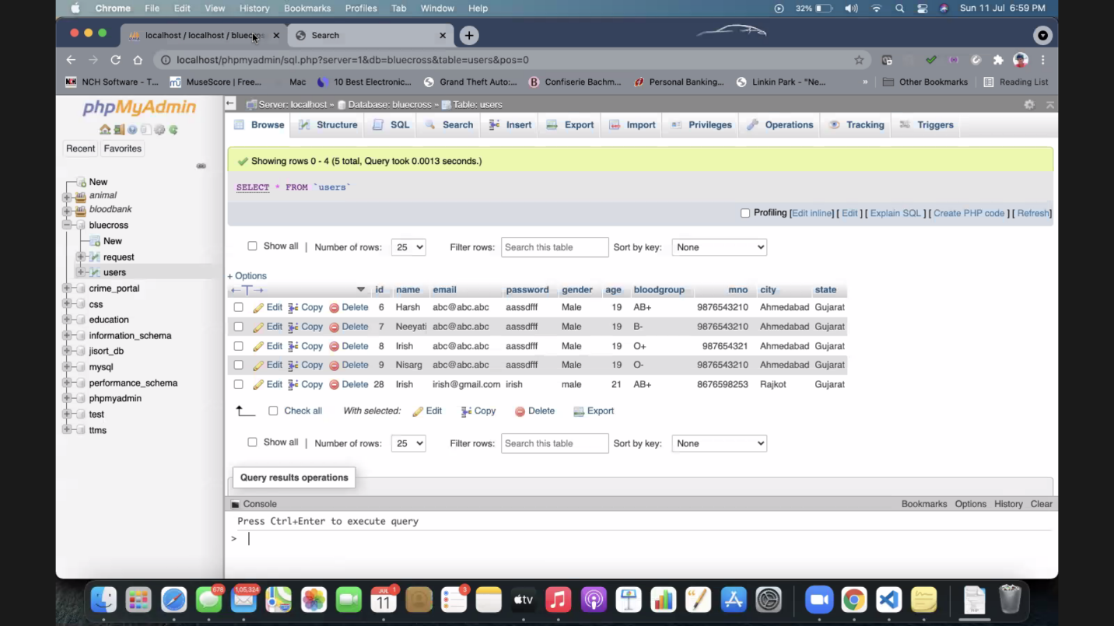

**Here’s our Database of the student ‘irish’**

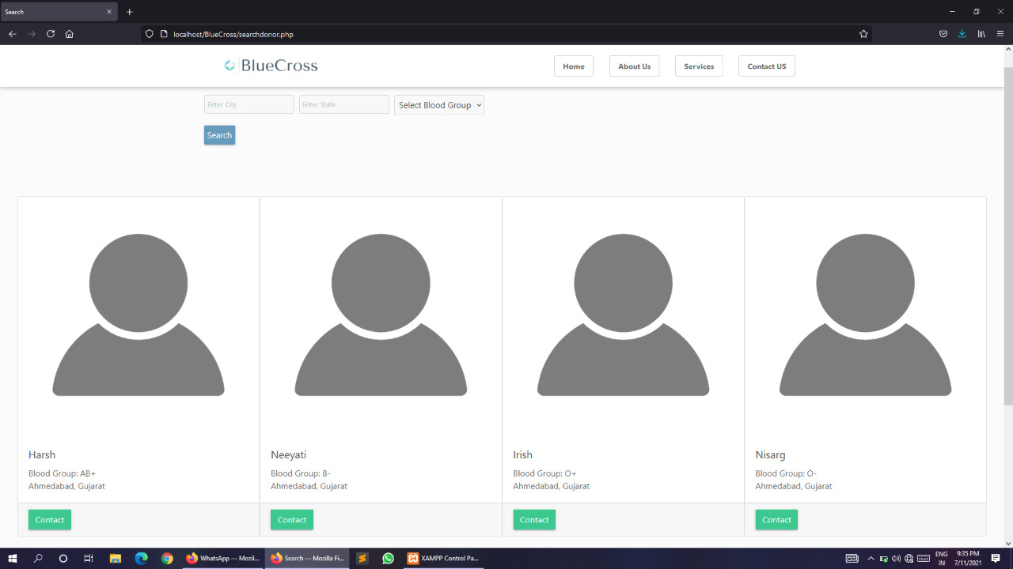

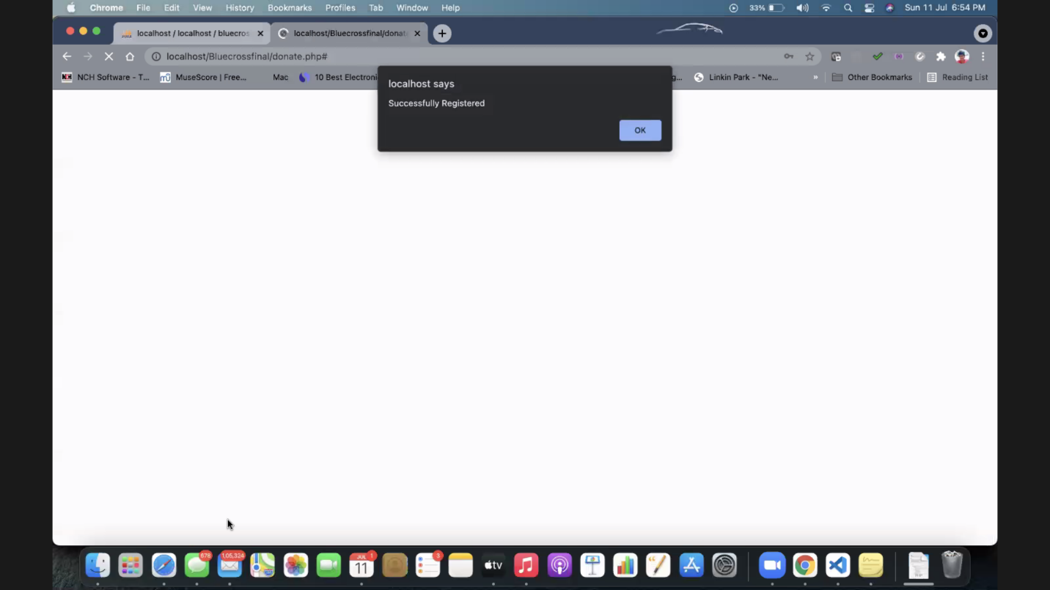**Here are the data being represented**

**After entering the correct data for the blood donor form, the student “irish” has successfully logged in and the above alert is being displayed after the process has been completed.**

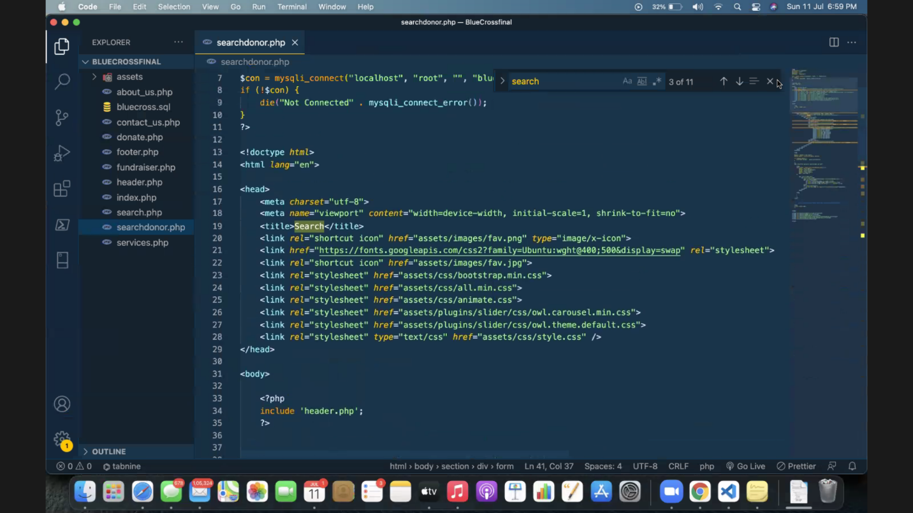

**Here’s a picture of our code**